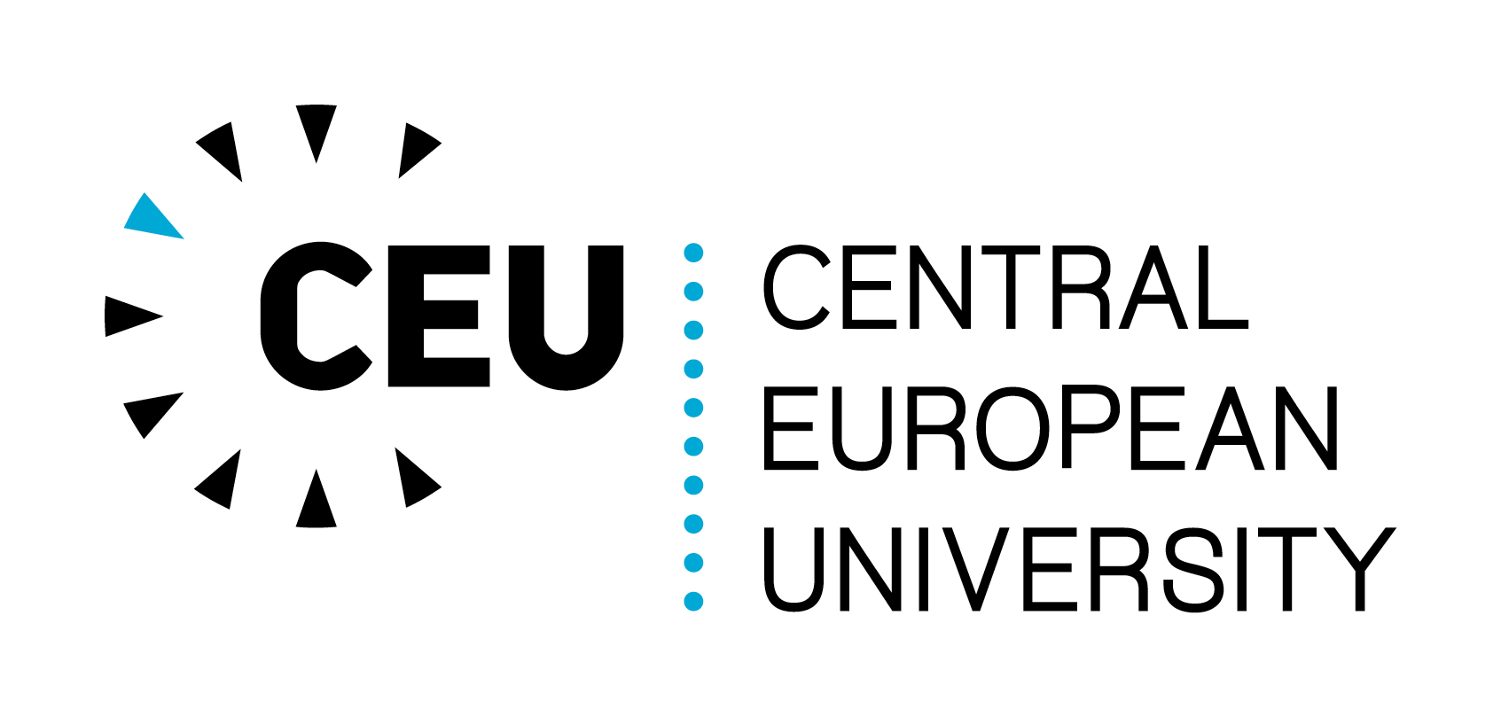 | Central European University  Budapest Hungary  CEU OFFICIAL DOCUMENT
ANNOUNCEMENT AND CALL FOR APPLICATIONS

CEU Teaching Development Grants

CEU Teaching Development Grants to support individual faculty members in the development of teaching projects are available on a competitive basis with funds up to 2,000 euros per project per academic year. Teaching Development Projects should be designed to focus on inquiry and experimentation, particularly in areas outlined in the CEU Strategic Plan: greater development of connections between research and teaching; using new technologies to support learning; incorporation of problem-based learning; teaching with case studies; the development of interdisciplinary approaches to teaching; and other research-based teaching strategies.
Teaching Development Grant funds may be used to hire a doctoral student to serve as a Teaching Development Grant project assistant, to attend teaching-related workshops and conferences, or to purchase software or other teaching-related equipment or materials required for implementation of the teaching development project. The fund may not be used for faculty salary support. Grants will be available annually on a competitive basis. CEU teaching faculty members who hold formal CEU faculty appointment and rank with the University over the period of the project are eligible to apply.

Project Support from the CEU Center for Teaching and Learning
Grant recipients may choose to work with CEU’s Center for Teaching and Learning (CTL) through all phases of their teaching innovation projects. In such cases, CTL faculty are available to collaborate with individual faculty members to explore teaching ideas and challenges that interest applicants as they develop their project proposal; consult with interested faculty members and doctoral student project assistants as they develop their ideas into pilots and small-scale teaching innovations; and share feedback and research insights during the implementation of the projects and follow-up activities, including possible video documentation and analysis.

Review Process and Criteria
The call for applications for CEU Teaching Development Grants will be announced at the beginning of each academic year and will be awarded in two cycles:

First funding cycle of the 2017-2018 AY: Applications for projects to begin during academic year 2017-2018 are due on 15 November 2017. Grant awards for this cycle will be announced in December 2017.
Second funding cycle of the 2017-2018 AY: Applications for projects to begin in the next academic year in 2018-2019 will be due on 2 May 2018. Grant awards for this cycle will be announced in June 2018.
Applications will be reviewed by the Provost and 2-3 additional rotating faculty members. The acting director of the CTL will serve ex officio.
Projects will be evaluated according to the following criteria:
- Clear articulation of the motivation for undertaking the project, project goals, and plan for future on-going development;
- Feasibility;
- Potential to improve student learning;
- Compatibility with the CEU Strategic Plan;
- Meaningful use of technology to support student learning (in the case of innovation projects focusing on technology integration;
- Budget.
Projects should be completed within one year, and a short final, narrative report will be required within three months of project completion. There’s no need to submit a financial report.
Questions regarding budget and personnel cost calculation, as well as the applications and reporting information should be directed to Veronika Csapó of ACRO at: csapov@ceu.edu.
If applicants wish to meet with faculty members at the CTL to discuss their teaching project ideas, please contact Sally Schwager at: sschwager@ceu.edu.

