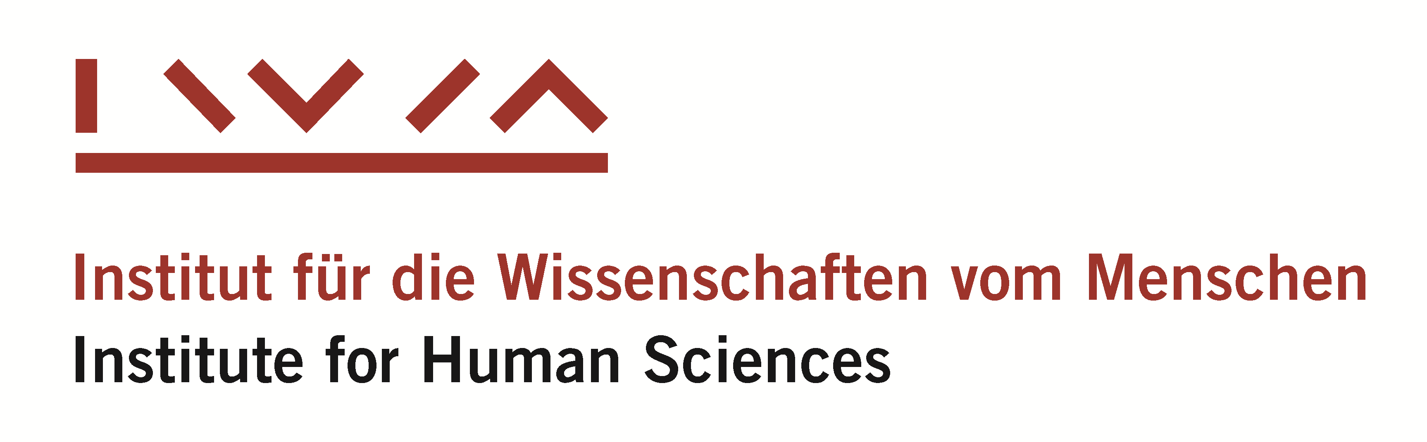

CEU Junior Visiting Fellowships

at the Institute for Human Sciences, Vienna

2017 – 2018

Call for Applications

Objective
The joint fellowship program of Central European University and the Institute for Human Sciences (Institut für die Wissenschaften vom Menschen, IWM) in Vienna supports CEU Doctoral Students who would like to pursue research as junior visiting fellows at the IWM.
Applications are welcome in any topic in the humanities and social sciences which relates to research pursued at the IWM. Applicants are asked to consult the Institute's website (www.iwm.at) to check whether their research topic fits the Institute's profile.
The main research fields of the IWM include the following topics:
- Scales of Justice and Legal Pluralism
- Religion and Secularism
- Democracy in Question
- Demography and Democracy changing
- Justifications of Wealth
- United Europe – Divided History
- Economic Ideas and Institutions in Eastern Europe
- The Philosophical Work of Jan Patočka
- International Law and Multinormativity
- Sources of Inequality

Conditions
The CEU Junior Visiting Fellows will spend a five-month term between October 2017 and June 2018 in residence at the IWM in Vienna, while pursuing their research projects as members of the Institute’s international scholarly community. The IWM will provide an office, IT, administrative and research infrastructure to the Fellows. The Fellows will receive a stipend in the amount of EUR 1,700 per month to cover travel, accommodation, health insurance, research expenses and incidentals during the stay at the IWM.

It is envisaged that students who already exhausted their CEU doctoral stipends will especially benefit from the opportunity offered by the Fellowship, but students who are receiving their stipends are also eligible to apply. In case a student who is required to be in residence in Budapest receives a fellowship, he or she should, as usual for any prolonged period of absence, obtain permission from his or her Doctoral Program Committee before commencing their fellowship. The CEU doctoral stipend is suspended for the period of the Fellowship, but the five months are added to the period of the doctoral stipend after the Fellowship concludes.

Eligibility
Candidates for the Fellowship must be enrolled in a doctoral program in any discipline at CEU. The topic of their Ph.D. dissertation must have been approved.

Application
The application consists of the following:
- application form (attached)
- project proposal in English (not more than 3 double-spaced pages)
- curriculum vitae including a list of publications
- a letter of recommendation from the thesis supervisor and a second letter of recommendation
- CEU transcript (printout from Infosys)

Deadline for application is September 10, 2017

Please deliver or send your application as e-mail attachments (PDF) to:
Noemi Anna Kovács
European Cooperation Projects Officer, ACRO
kovacsn@ceu.edu
Subject header: CEU-IWM Junior Visiting Fellowship

Please note, that Letters of Recommendation should be sent separately by the referees to the same e-mail address.

A jury consisting of academic members of the IWM and CEU will evaluate the applications and select the finalists. Applicants will be informed about the decision within two weeks.

The jury is not required to publicly justify its decisions.

